**EXPERIMENT NUMBER – 01**

For this experiment we have displayed all the webpages created using HTML.



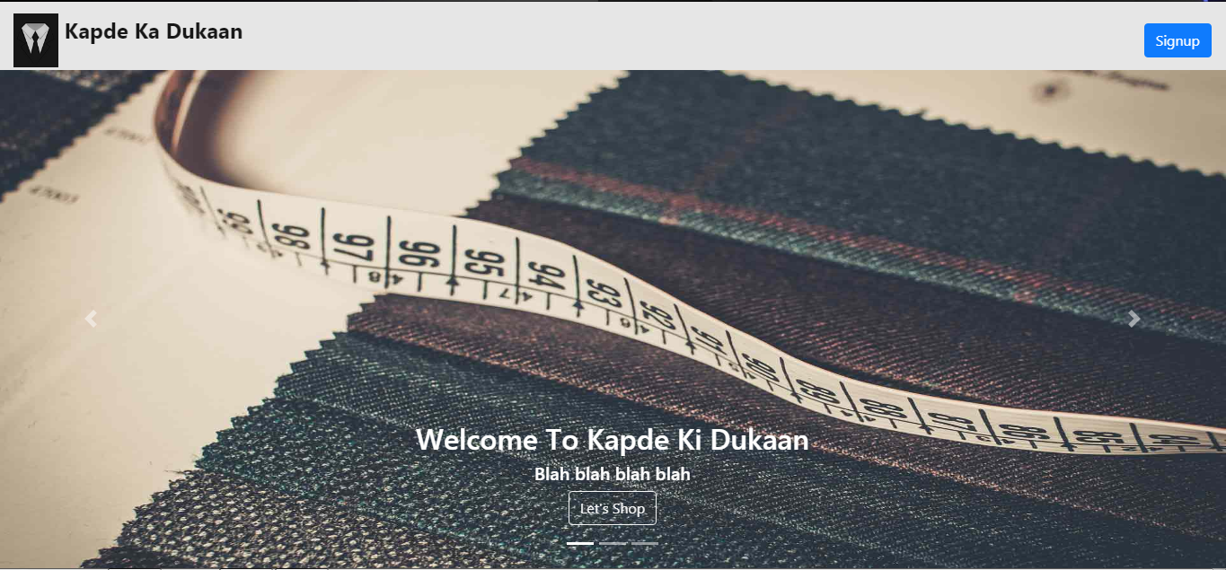This slider gives the user an overall idea of what our webiste contains displaying various images.Clicking on Let’s Shop, this is how our website looks offering various designs and patterns of different cloth material samples, which when hovered will display their price and more detailed options.

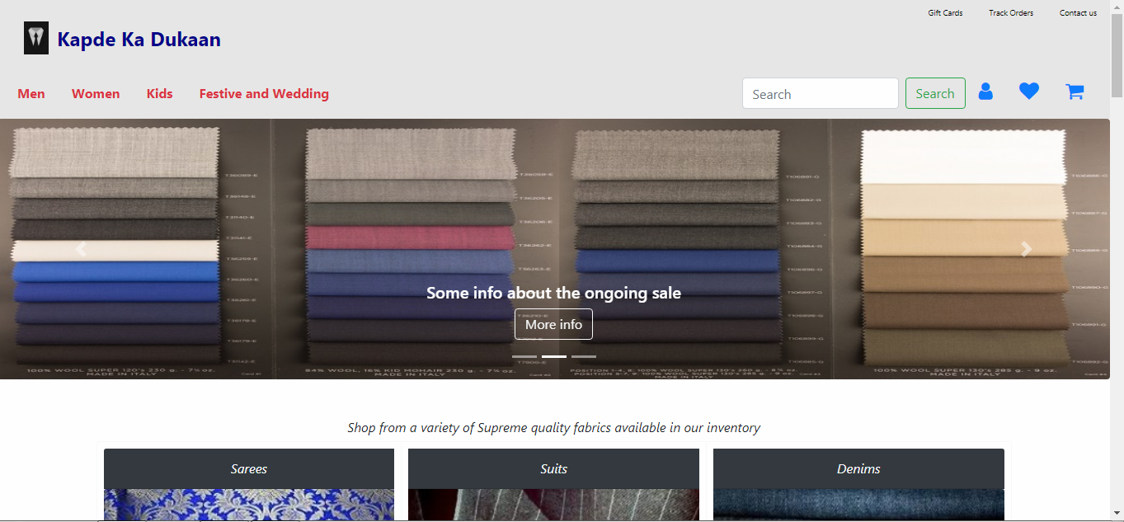

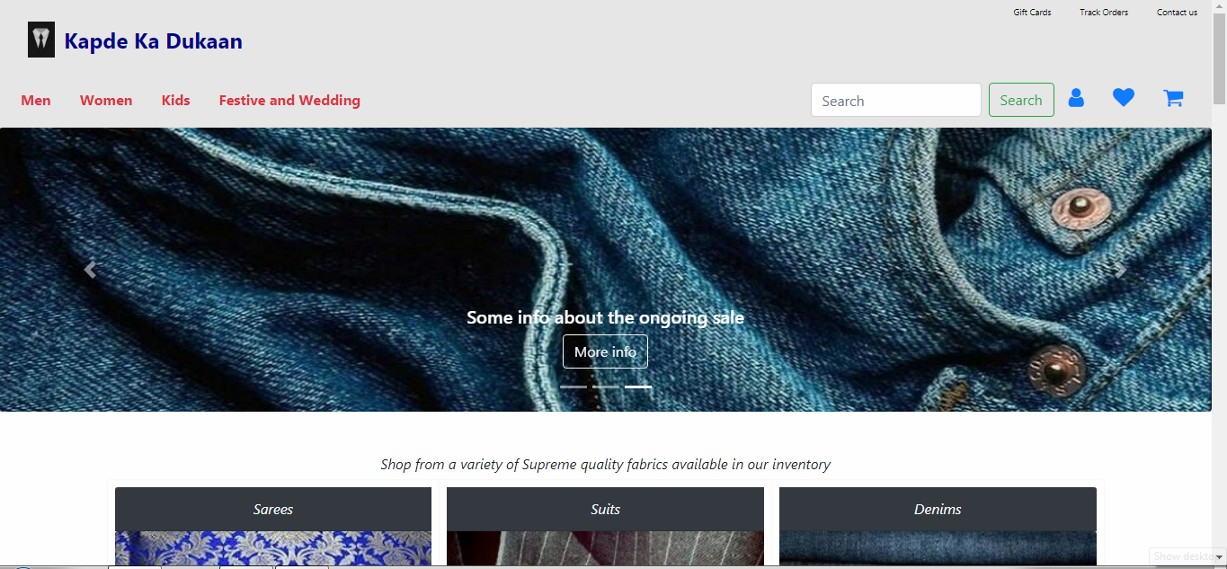

As you can see if the user wants to search something, we have created a Navigation bar to optimize their search. Also there are various options already available for him to select his product with descriptions provided once image is hovered.

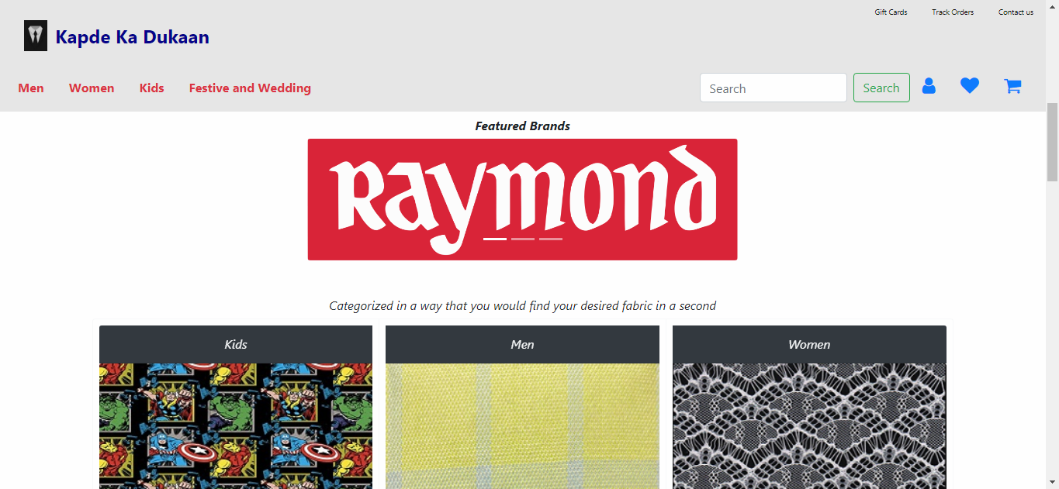

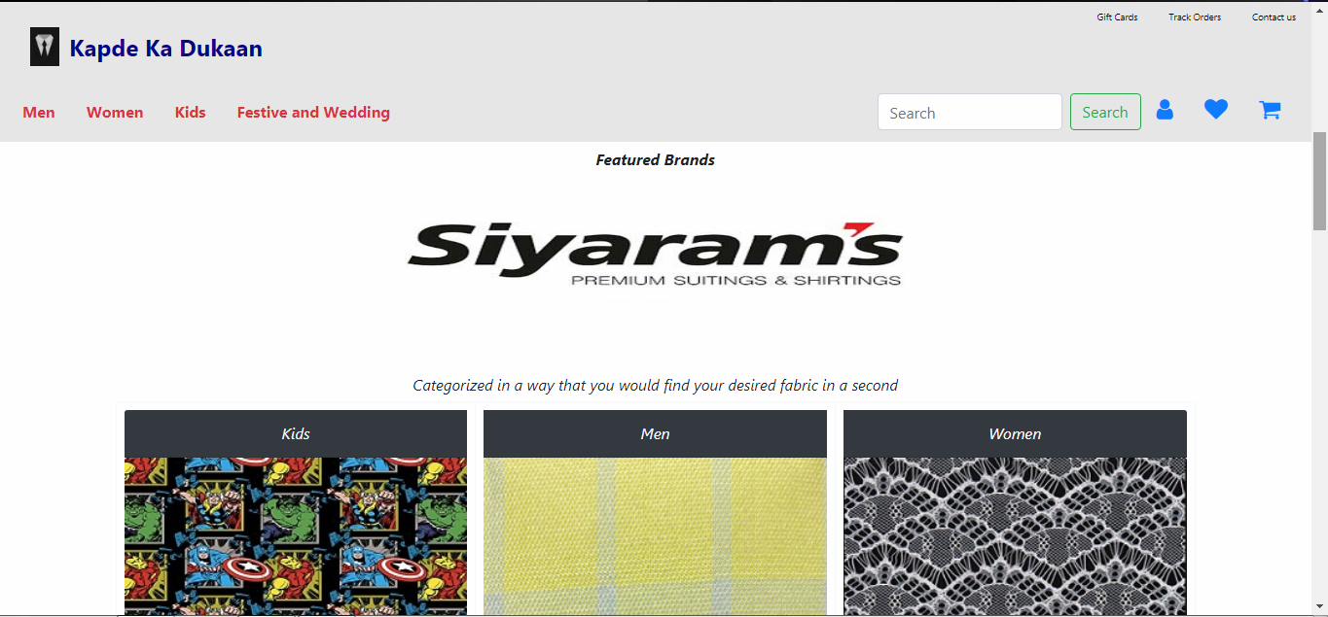

We have also added some featured brand banners/flash-cards which helped us to make our website look better also aware about our content.

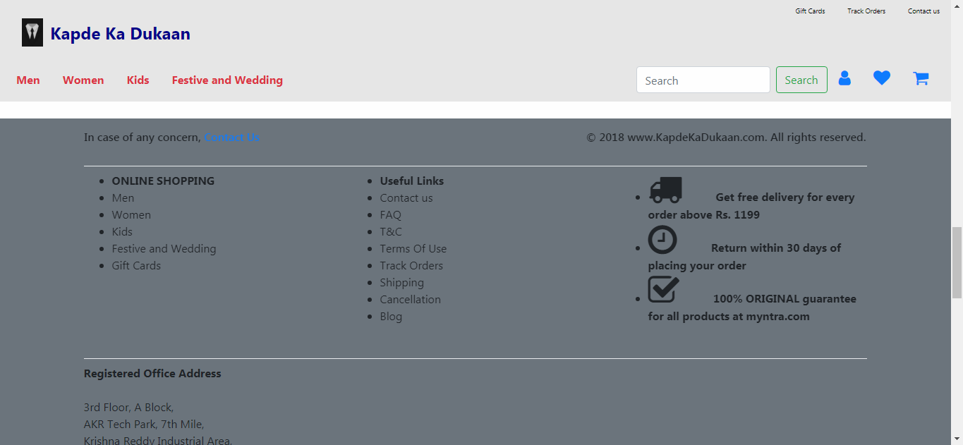

As one comes to the last while scrolling, a footer appears which displays information about our team which has worked on this website. The footer only appears if you have reached towards the end of your webpage.

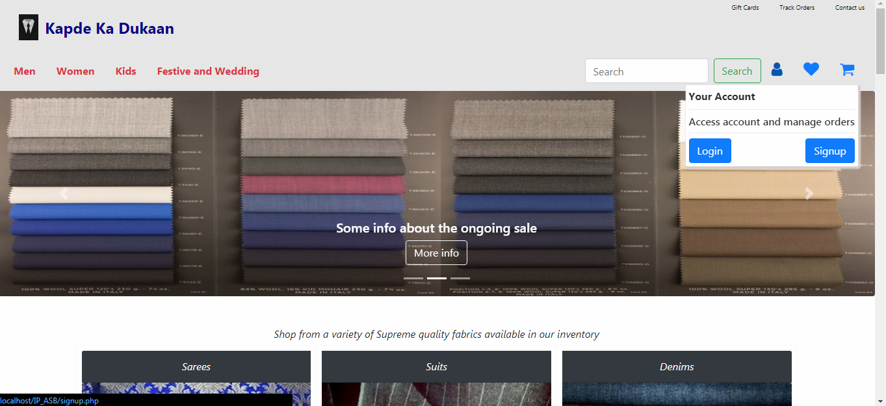

If a person is visiting our website frequently, he can LogIn, or if he is visiting for the first time and wants to make an account, he can do so from the Your Account button which has the desired options displayed once hovered.

**EXPERIMENT NUMBER – 02**

For this Experiment we have tried to make our website responsive.

 

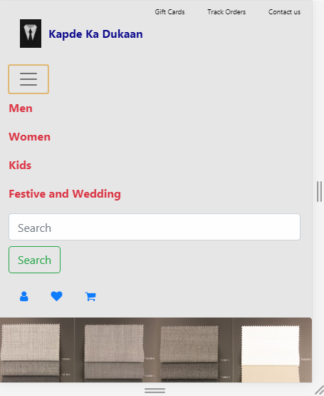 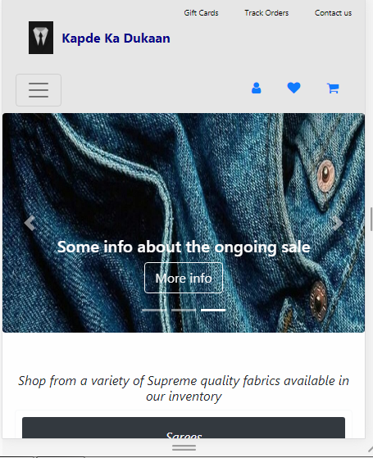

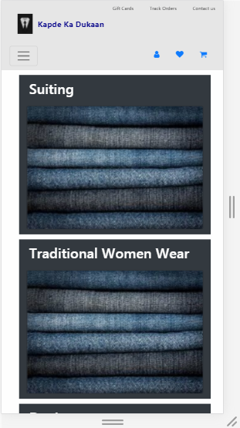 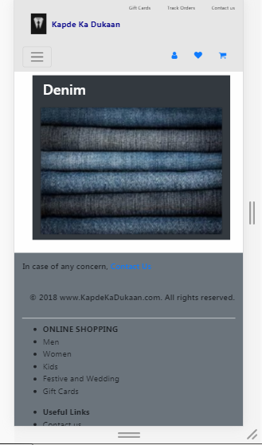

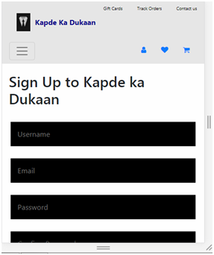 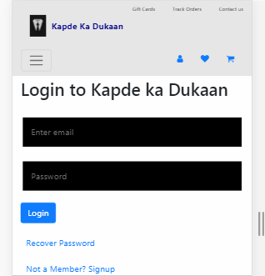

**EXPERIMENT NUMBER – 03**

For this Experiment we have displayed all the pages where CSS is used, and how.

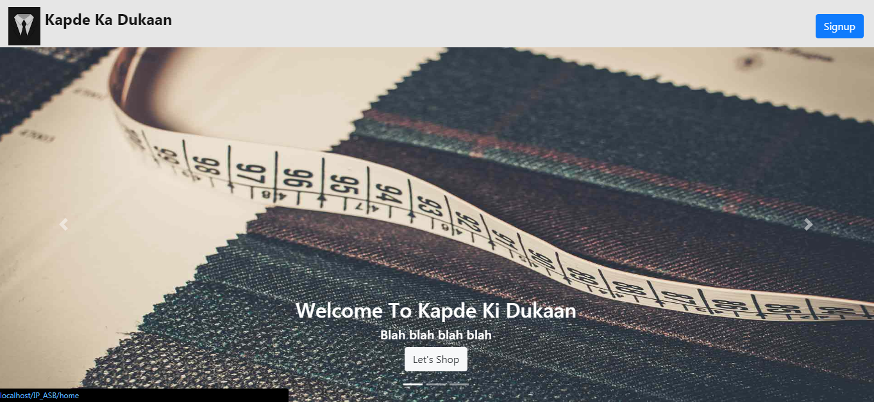

The lets shop button when hovered, displays button with background color which is done using CSS.  
  
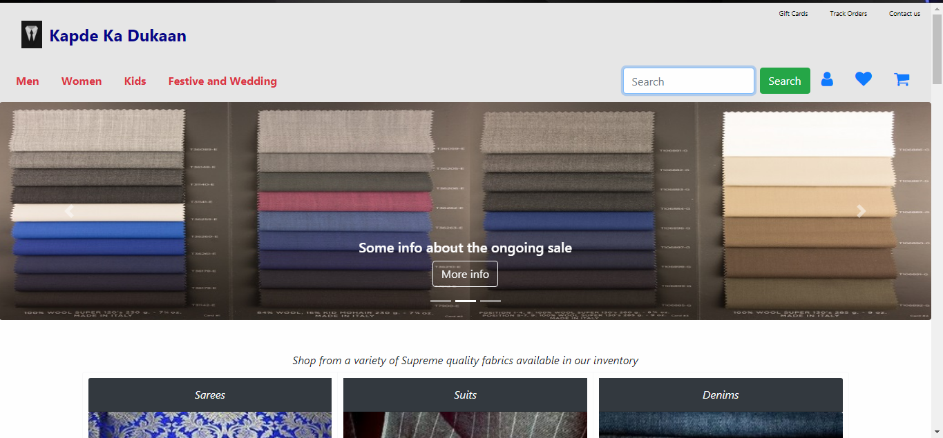  
When the search button is clicked, it changes its color and when we click on the search-bar it gets highlighted.

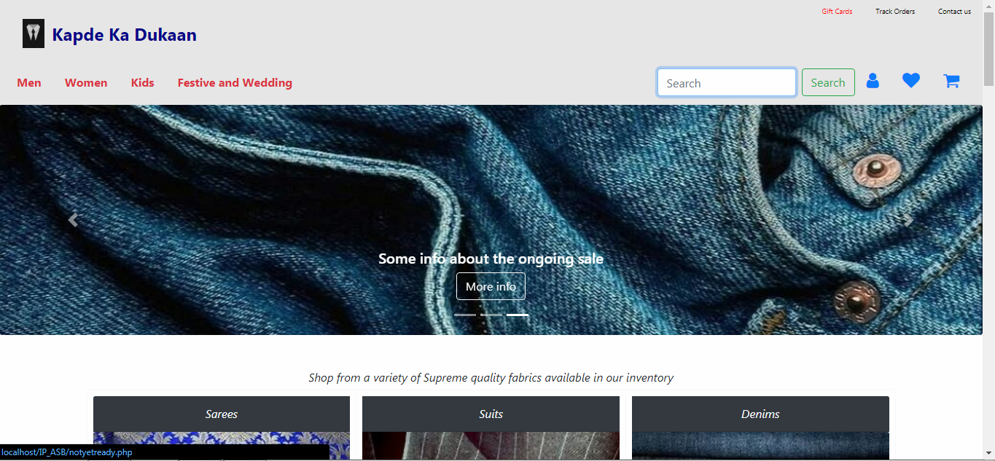

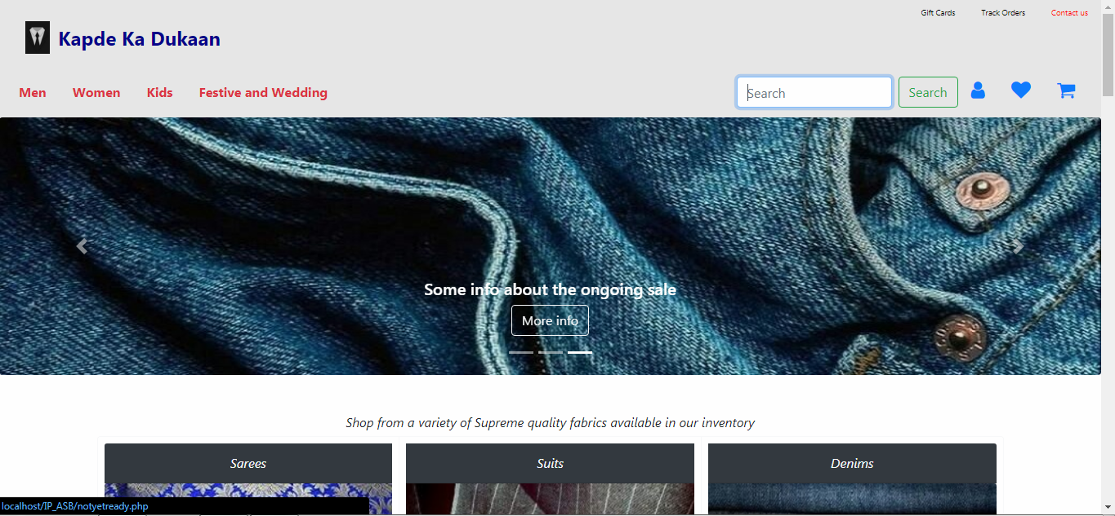  
These extra buttons change their color when hovered, and also the “More Info” button.

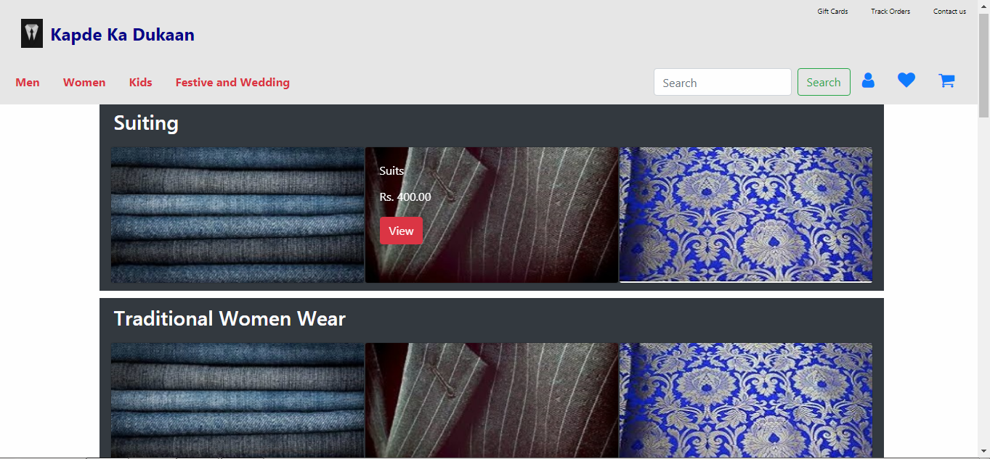

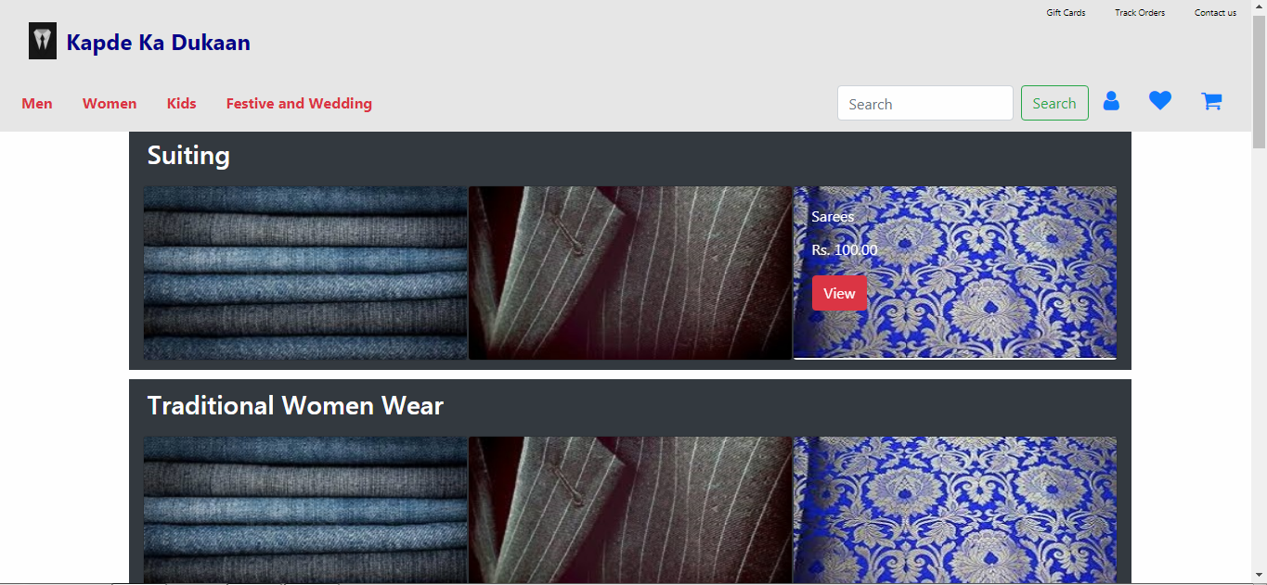

The products when viewed in the Men, Women, Kids or Festive section will display details of the given product i.e. its type, its cost and options to view details of it. All of these special features are given by CSS.

**EXPERIMENT NUMBER – 05**

In this Experiment we have to show Javascript validation of Forms used.

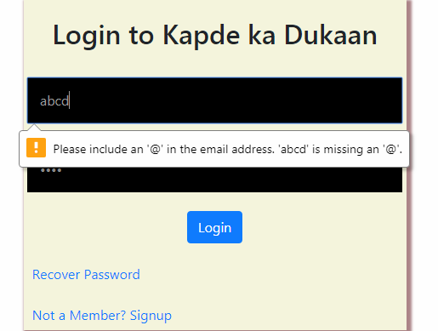 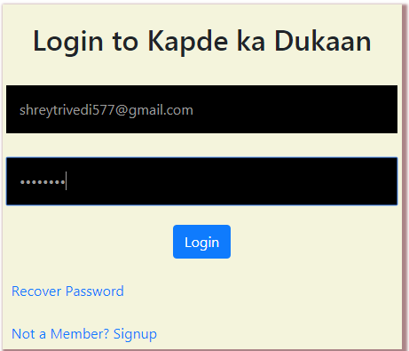

This experiment focuses on validation of forms used for various purposes in our website using Javascript. It basically helps us to cross check or verify the details filled by people using this website to either login or signup, etc into such websites. It also helps the developers to keep a track of all the users and their data stored in the form of cookies.

